Frequently Asked Questions by GPs

Accounts Tests & Guides

How do I open an Account?
Please download and complete the 2 sets of forms from our resource webpage for Healthcare Professionals and return them as instructed. This process can take up to 7 working days depending on the volume of requests.

Where can I see a list of the tests that Eurofins Biomnis provide?
Visit our A-Z test guide on our website. You can search alphabetically or enter the name of the test
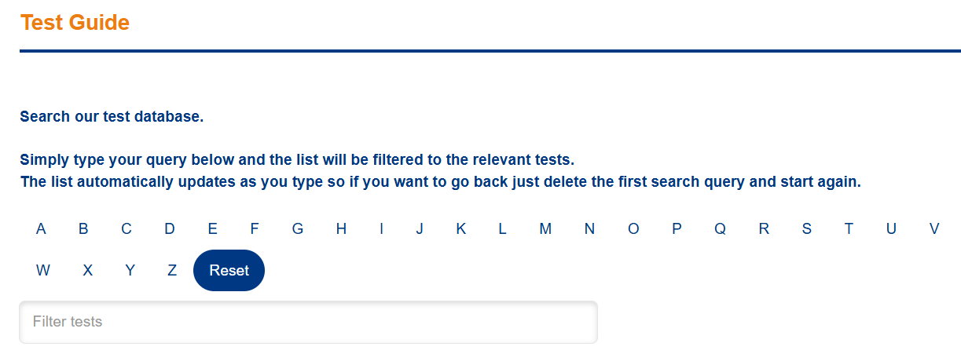
Image 1
Alternatively, you can view the Primary Sample Manual webpage and search the PDF’s on that page.
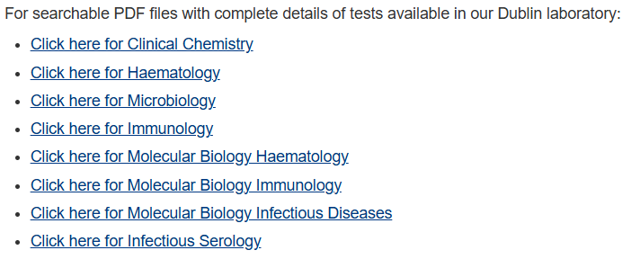
Image 2

Where do I get a price for tests?
Client Services may be able to provide a price for a standard test – email clientservices@ctie.eurofinseu.com or call1800 252 966. Otherwise email sales@ctie.eurofinseu.com for customised profiles or more specialist tests.

Is there a charge for Kits / test consumables?
Yes, there is a charge for kits, unless you have agreed a special inclusive price with Eurofins Biomnis. Contact our Client Services team for prices or ask the Orders team for a quotation when you are ordering test consumables. To facilitate clients, we provide an end-to-end medical testing service which is why we have a test consumables store. This store is only available to clients.

How do I order test consumables?
When you open an account with Eurofins Biomnis, you are asked if you need test consumables. Once your account is open and you will be alerted when it is, email orders@ctie.eurofinseu.com using the Orders Form , which you will find on the resource page for Healthcare Professionals.

How do I use the test Kits?
We have guides to help you use the kits that we supply. These guides are downloadable from the Resource page for Healthcare Professionals.
- Urine sample collection guide
- Cobas vaginal swab collection guide
- FIT Sample collection guide
Please note the urine cobas kit is yellow and the multi-site swab is pink to help you distinguish between them.
Urine Collection Kit (yellow):
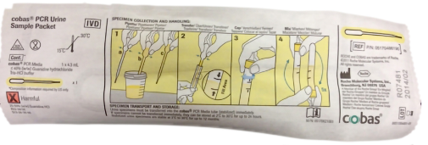
Dual-Swab Collection Kit (pink):
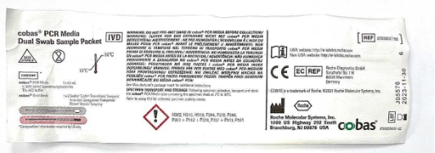
Image 3

How do I send an Urgent Sample?
We have prepared a guide to help you send your Urgent Samples. Visit the resource webpage for Healthcare Professionals on our website to view our Sample Packing guide. Potassium, Phosphate, INR and Quantiferon are URGENT samples and need to be put into a red sample bag. For other Urgent Requests, please provide clinical reasons along with Out of Hours contact number and name of the Requesting Clinician. In the absence of these details, the test request will be processed as routine.
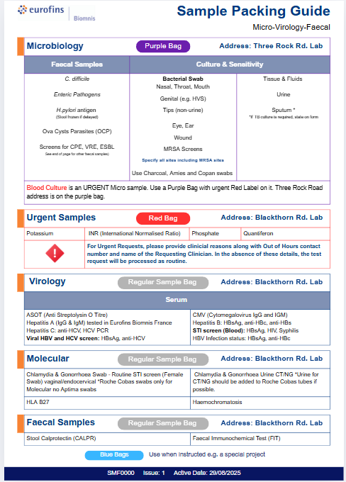
Image 4

What Microbiology Tests do you perform?
Visit our A-Z test guide to search and view all of our microbiology tests. You can read more about our Microbiology Laboratory and our team under ‘Our Laboratories’ on our home webpage. You can also download our Microbiology Primary Sample Manual, found at the end of that webpage.

Are there special packing instructions for Microbiology tests?
All micro samples are to be put into a purple bag to ensure they are delivered to the Micro Lab based at Three Rock Road in Sandyford, separate from our other Lab at Blackthorn Road in Sandyford. Our orders team supply these sample bags and you order them from our test consumables store using the order form. Visit the resource page for Healthcare Professionals on our website to view our Sample Packing guide and to download the orders form.
 | Microbiology Samples | All Other Samples
Packaging | Biohazard bag with the test request form in the outside pocket of the bag and then package into our Purple Bag  When micro samples are urgent, e.g. blood culture, use the purple bag with the urgent sticker on it. | Biohazard bag with the test request form in the outside pocket of the bag and then package into  Red Bag for Urgent Samples
Address | Eurofins Biomnis Microbiology  Three Rock Road,  Sandyford Business Estate  DUBLIN 18,  D18 A4C0 | Eurofins Biomnis  Unit 3, Sandyford Business Centre,  Sandyford Business Park,  Blackthorn Road,  DUBLIN 18  D18 E528
Microbiology Test Kit requirement | Charcoal Amine Swabs, Liquid Swans (Amies Transport Medium), Cobas Swabs | Swabs to avoid: Dry & Aptima Swabs

What is the latest time that samples can be delivered to the lab?
Samples can be delivered to Eurofins Biomnis locations up until 5.30 pm, Monday to Friday. Contact our Client Services team if you need to deliver outside of these hours, subject to additional charge.

Ordering Tests & Accessing test Results

How do I order tests from Eurofins Biomnis having opened an account?

Eurofins Biomnis is moving away from using paper request forms for 4 reasons:
1. Client Preferences: Increasing requests from clients for digital results, which are easier to report, filter and file.
2. Environmental Impact: The need to reduce paper usage to mitigate deforestation and its associated greenhouse gas emissions and waste.
3. Security: Enhanced protection against breaches and unauthorised access through digital storage.
4. Technological Support: Availability of our secure results portal, CDx Connect, which can also serve as a backup to existing IT systems.
Having opened an account with Eurofins Biomnis, we will get you set up for electronic ordering and access to results. From requesting an account to getting set up on Orcis takes about 2 weeks. A member of our on-boarding team will get in touch, gather information on your test requirements and build a customised test page for you and your team.
Meanwhile, there are paper test forms on the website which you can complete and submit with your samples.

How do I use Orcis, your electronic ordering system?
You can view the Orcis tutorial video from the Healthcare Professional resource webpage and this video takes you through the process step-by-step. There is also a User manual available for download. In addition, we run regular live tutorials, which you can attend and ask your questions in a live session.
If for any reason ORCIS is not loading correctly, you can refresh the page by clicking ctrl + F5 on your keyboard or by holding ctrl + shift and clicking ‘R’.

How do I access my test results?
At the moment, our LIMS system does not allow us to email results, but a new system has been purchased and will be in use soon. Our results platform, called CDx Connect, provides a secure desktop system where you can easily access results the moment they are authorised. As results are highly sensitive and private, we need to secure the written and signed permission of the Partner/Owner of the medical practice. This form is included in the ‘Open an Account’ form but is also available as an individual download on the resource page for Healthcare Professionals.
We run live on-boarding sessions for CDx Connect. Contact portal@ctie.eurofinseu.com to enquire about a session. You can also access a User manual on the resource webpage for Healthcare Professionals.

Can I create an alert to see results as soon as they are authorised?
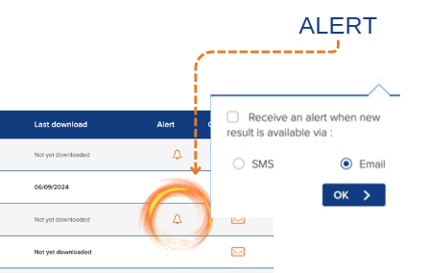
Yes, you can create an alert for a specific patient to receive a text message or email as soon as their results are authorised.

What format do my results appear on CDx Connect?
If you order a test profile which includes many tests, you can view partial results as soon as they are authorised. When all results are authorised, the best way to view them in full is to download the PDF for that patient.
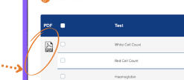

My test results are overdue, who do I call or email?
Email clientservices@ctie.eurofinseu.com or call 1800 252 966

Does my Patient Management System integrate with Orcis?
No. Orcis was custom-built by Eurofins Biomnis for its Irish Clients. It is a desktop system, accessed via an internet link. Orcis has a database which retains patient details therefore you need to enter patient data just once.

I want my Nurse or Advanced Nurse Practitioner to order tests and have access to their own results. Can you provide this service?
Yes, we can. The owner of the clinic or senior manager approves all users of CDx Connect. Our Client-Engagement team can assist you. Email: portal@ctie.eurofinseu.com

Do I need special paper?
Yes. We have A4 size paper called ‘Orcis Paper’ that you can order from our Orders Dept. It has 8 peel-away labels at the end which you attach to your samples. This is all explained in the video and user manual. This paper can be ordered via orders@ctie.eurofinseu.com and there is no charge.

Do I need a Special Printer?
No but following are some tips to help ensure the labels are properly aligned.

In Printer Settings, there is an option of “Print to Page” or “Print to printable area”, Select ‘Print to Page’. There can also be an option called Scale % and under this, select ‘Actual size’

Clinical Oversight

How do I access Clinical Advice?
Eurofins Biomnis provides clinical support via the Client Services team. At least two consultants are covering each laboratory discipline.
- Dr Mike Louw (Consultant Chemical Pathologist),
- Dr Rama Srinivasan (Consultant Chemical Pathologist),
- Dr Patrick Hayden and Dr Jeremy Sargent (Consultant Haematologists)
- Dr Con Feighery (Consultant Immunologist),
- Dr Brian Carey (Microbiology Consultant) and
- Prof Margaret Hannan (Infectious Serology/Molecular Biology Consultant)
- Dr Máire Lavelle and Dr George Harbourne and Dr Paul Downey
(Histology Consultants)
Each consultant can be contacted with clinical queries via Client Services clientservices@ctie.eurofinseu.com or call 1800 252 966

Who makes the Critical/Urgent Results Calls?
Eurofins Biomnis offer a 24/7 testing service making phone calls outside of hours. Normal working hours are Monday to Friday: 8.30am - 5.30pm.
Critical results will be phoned to your GP practice by Eurofins Biomnis. Please save this number, 01-5077131, to your mobile as "Eurofins Biomnis Critical Result". This is the only phone number that will be used to notify you of a critical result. In the event that we cannot reach a doctor, we ask clinicians to fill in the patient mobile number which we will only ring, if we cannot reach the patient’s doctor.

Can I order Tests for Private Patients?
Yes. At the end of the Resource webpage for Healthcare professionals are some of our most popular tests that clinicals order privately. These include Haemochromotosis, Vitamin D, Alex Allergy, Specialist Allergy Panels, Anti-Mullerian Hormone and the Pap Smear.

Genetic Testing

When do I need to have a patient sign a consent form?
The patient must sign a consent form before having a genetic test and understand the reason why the test is being performed. The consent form is downloadable from the ‘Test Request Forms’ webpage on our website.
- to confirm or invalidate the diagnosis of a genetic disease in relation to their symptoms, those of their minor child or those of the adult person under guardianship for whom they am the legal representative
- to confirm or deny the pre-symptomatic diagnosis of a genetic disease
- to identify a healthy carrier status (heterozygous or chromosomal rearrangement)
- to assess genetic susceptibility to disease or drug treatment.
IMPORTANT: Please complete the patient clinical details such as symptoms or family medical history, in the Genetic Test Request form to help the Testing clinician interpret the data and make a fully informed medical diagnosis.
What tests require a consent form?
SNP Array | Single gene | Panel gene
Exome test (WES) | All Chromosome tests | Karyotype testing
Array CGH | Any Pharmacogenetics to test reactions to meds
Any test from a medical specialism e.g. cardiogenetics or nephrogenomics

HLA (class I II III) | Hemochromatosis | Cystic Fibrosis
NIPT test | Fragile X | Gilbert syndrome
Prader-Willi syndrome | Angelman syndrome | Factor V Leiden
MTHFR | William’s Syndrome | Huntingtons Disease
Lactose Intolerance | Alpha 1-antitrypsin | Muscular Dystrophy
Prothrombin Factor II | Retts Syndrome | PAI-1
Table 1 – this is a non-exhaustive list

Who do I speak to at Eurofins Biomnis?

For your day-to-day queries and result queries
Email: clientservices@ctie.eurofinseu.com
Tel: 1800 252 966

For all logistic queries, quotes, requirements and orders that have been dispatched?
lablinklogistics@ctie.eurofinseu.com 1800 252 967

For all Medical kits, forms, samples bags, consumables
Email a completed Order Form (available under resources on the GP page) to
orders@ctie.eurofinseu.com

For all questions or issues with Orcis, our electronic and ordering port?

Email portal@ctie.eurofinseu.com to reach a member of our on-boarding team

